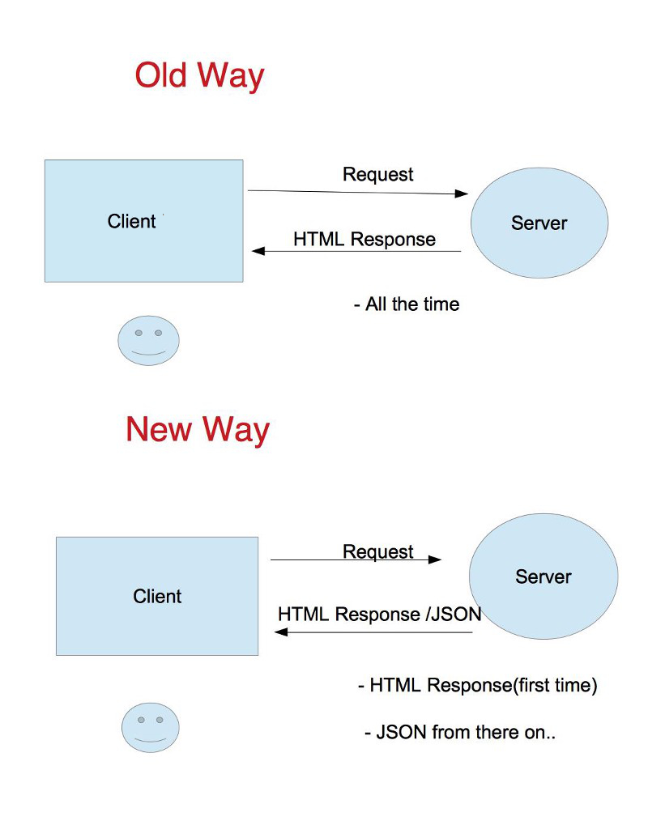

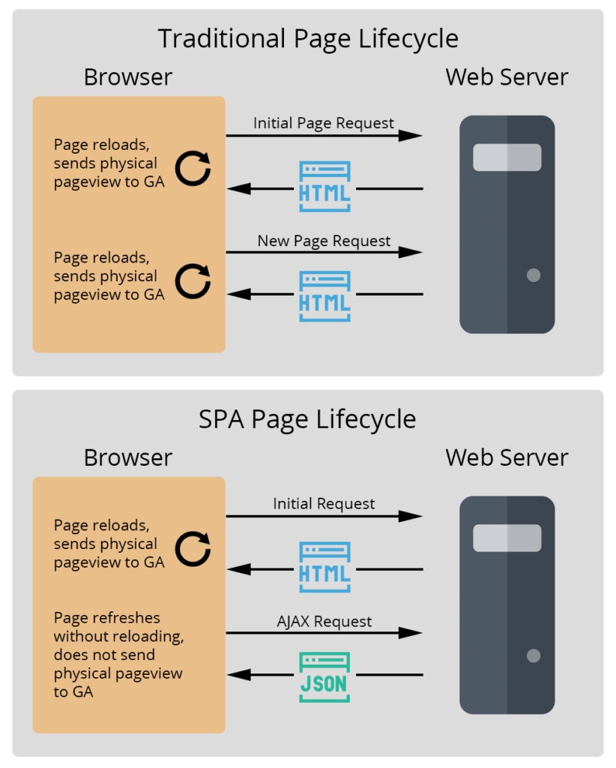

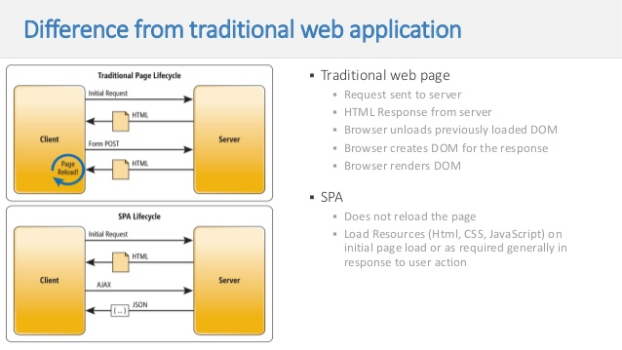

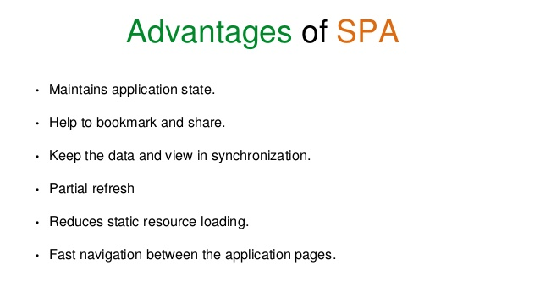

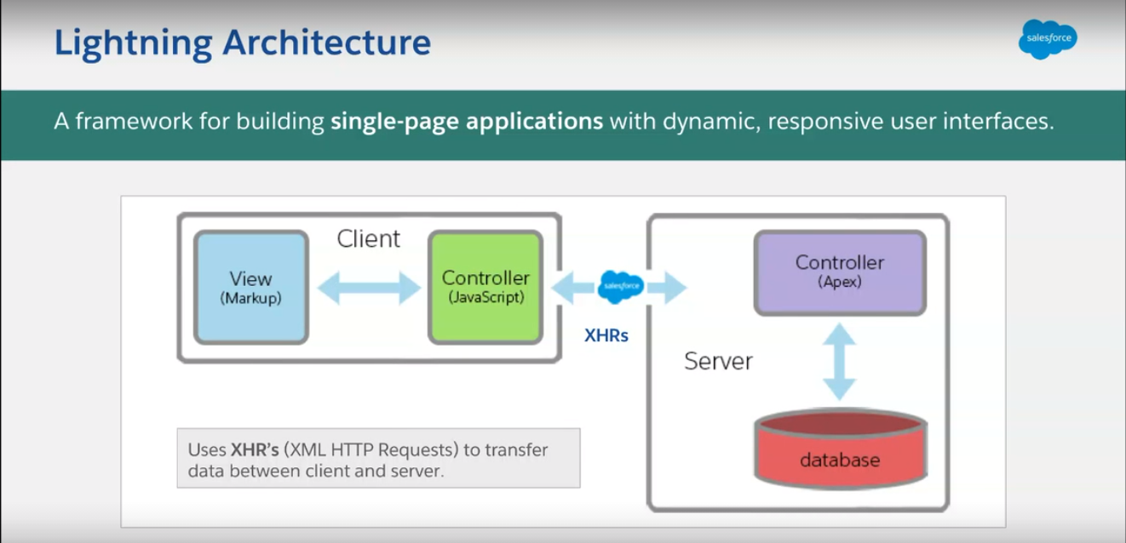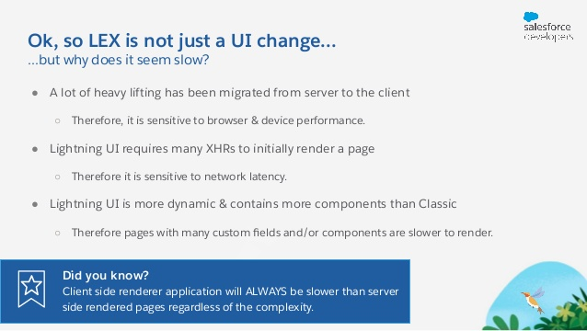

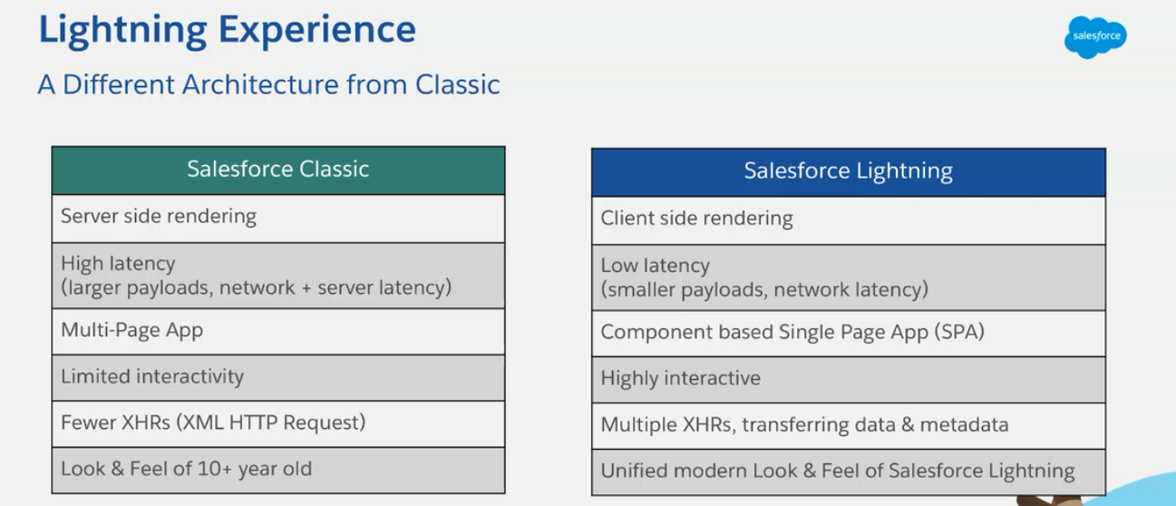

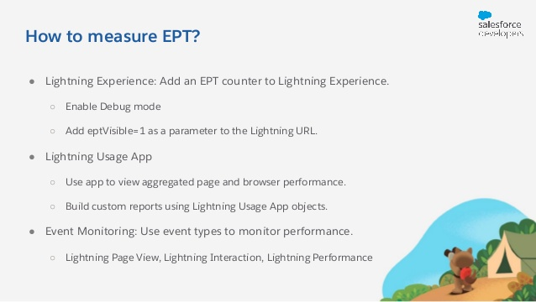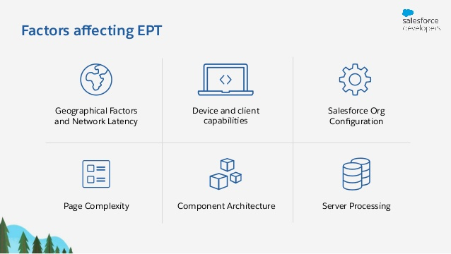

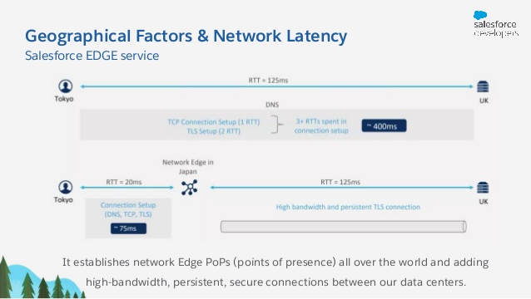

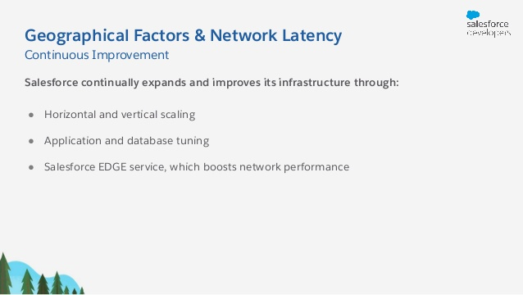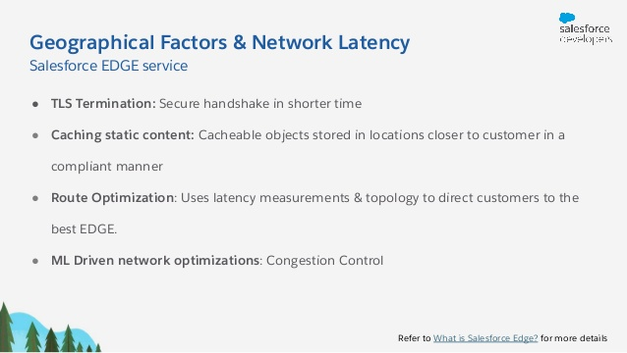

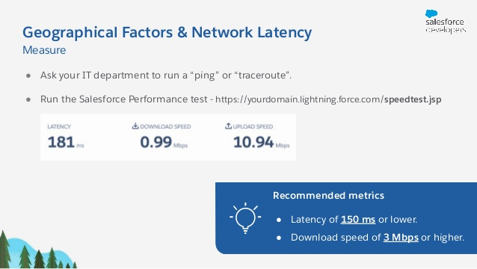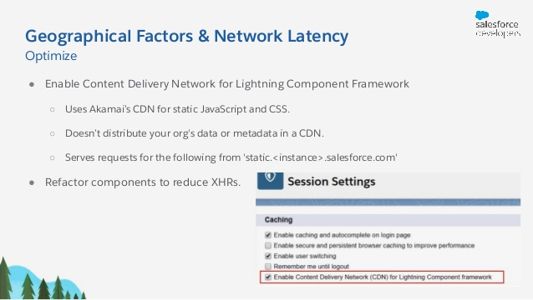

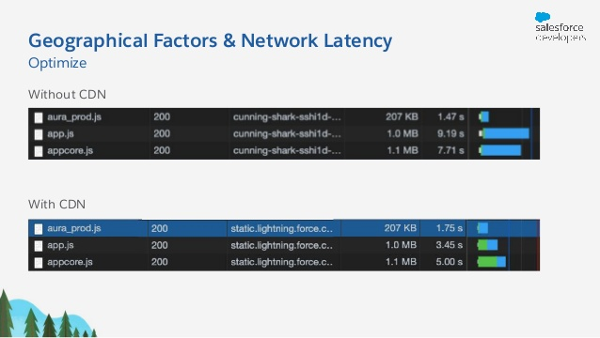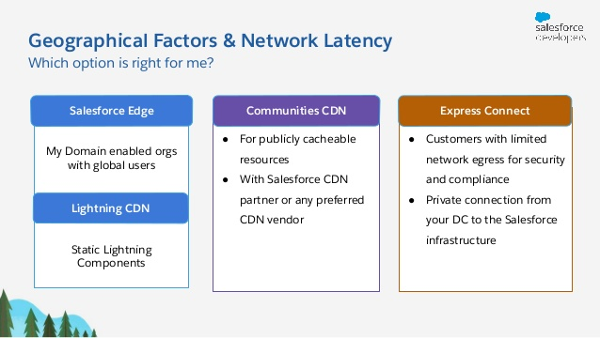

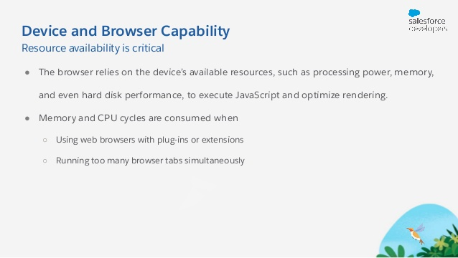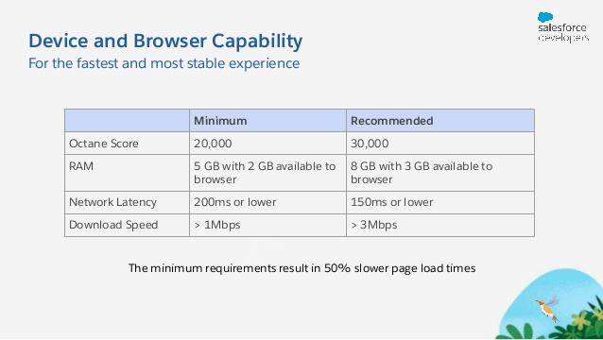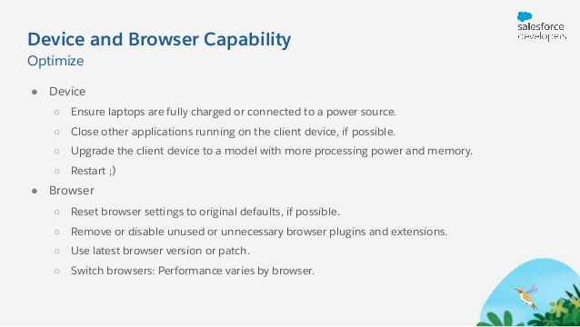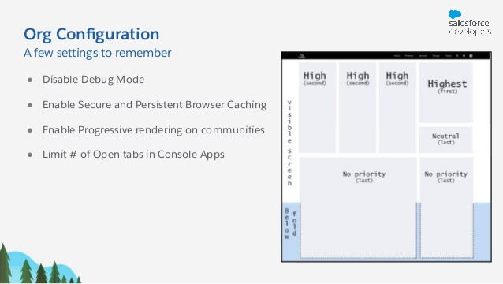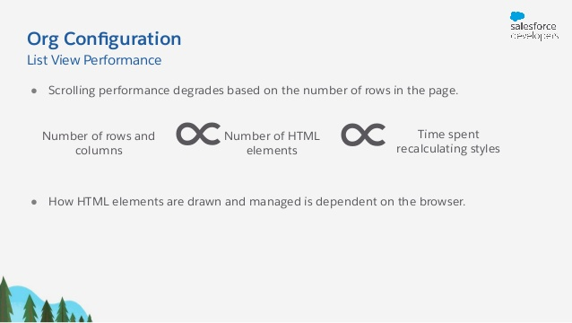

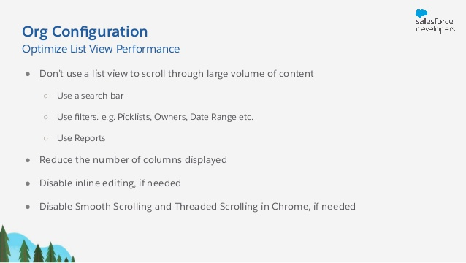



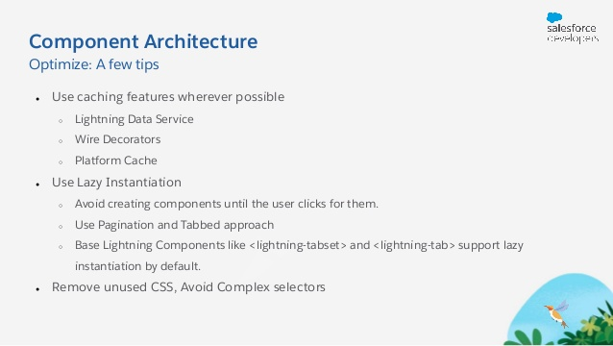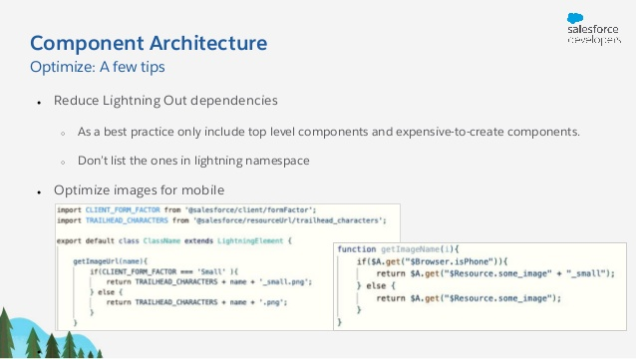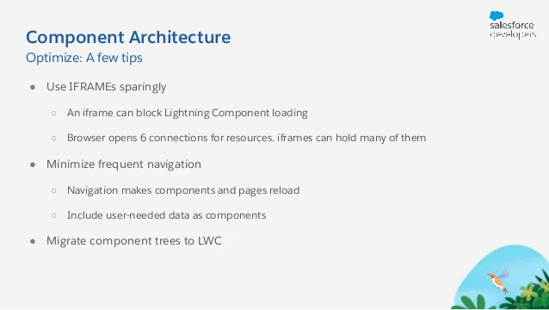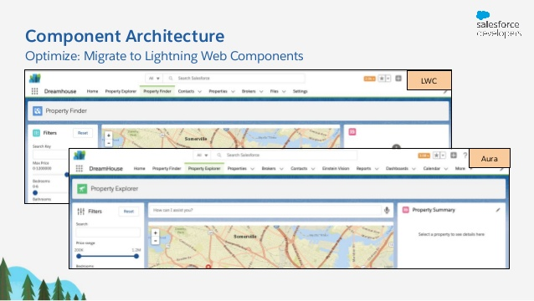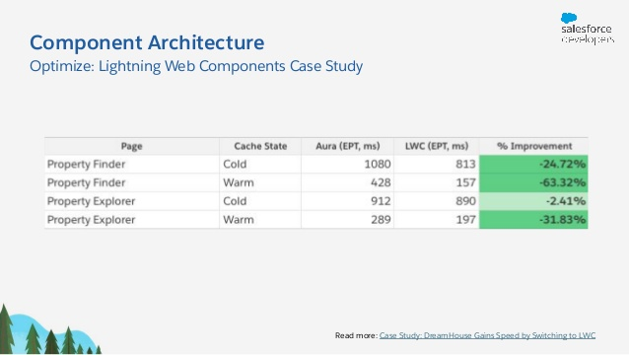

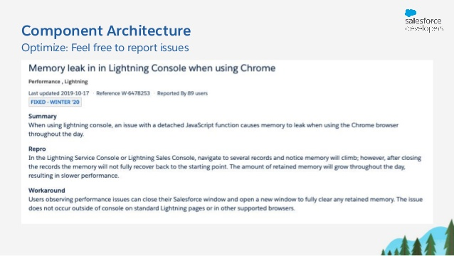

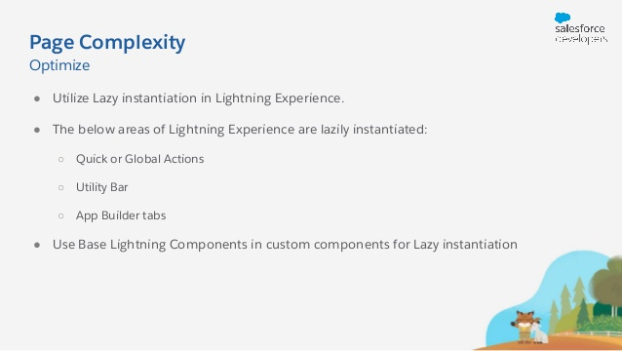

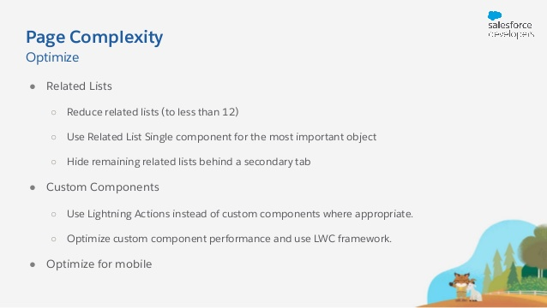

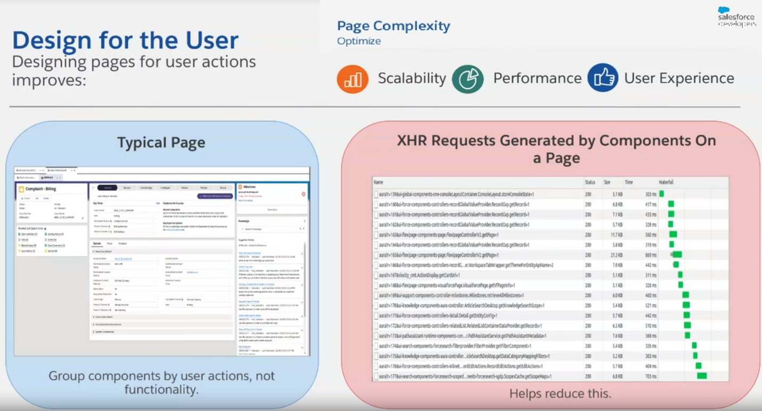

Tip-1

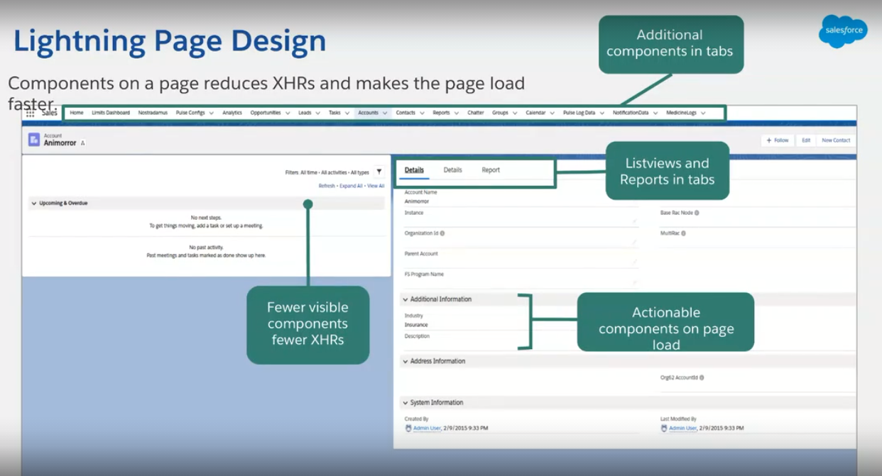

Tip-2

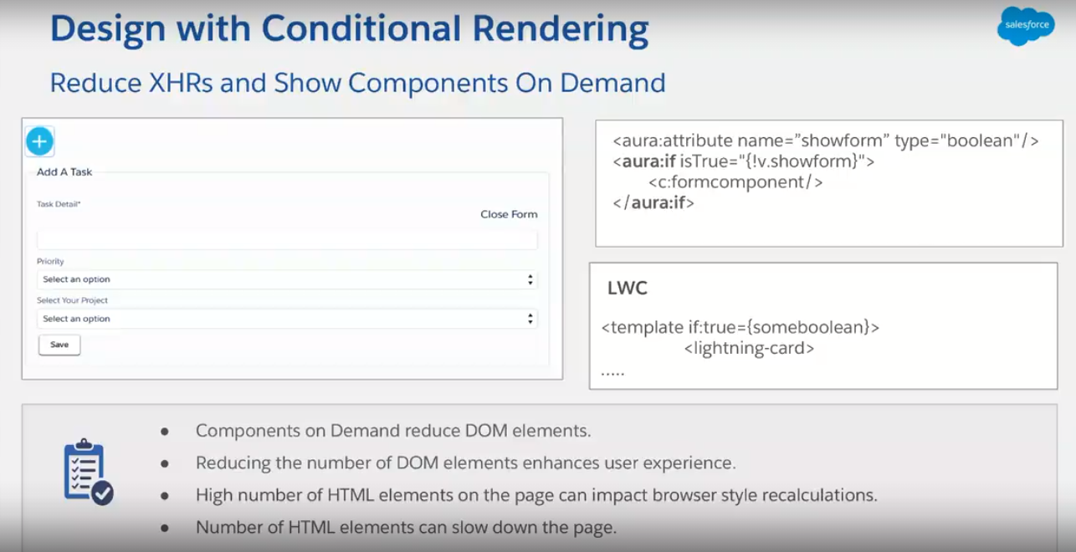

Tip-3

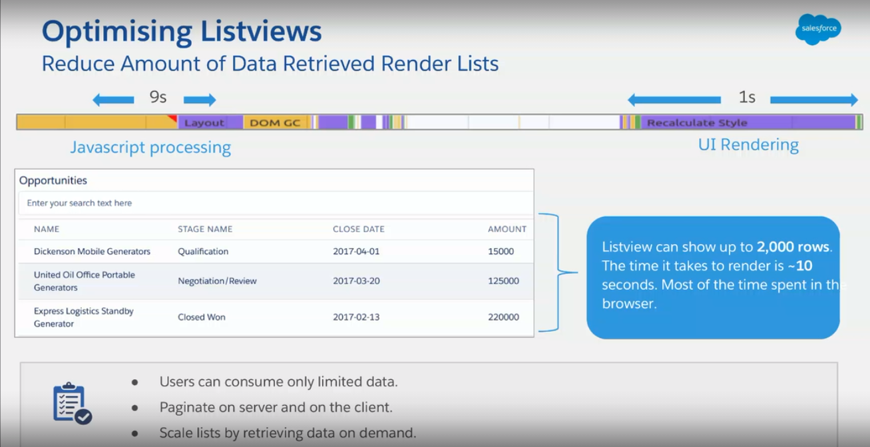

Tip-4

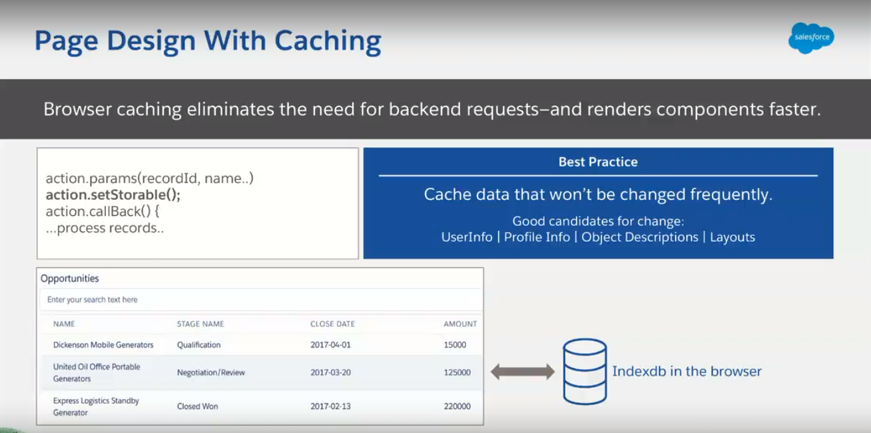

Tip-5



Tip-6

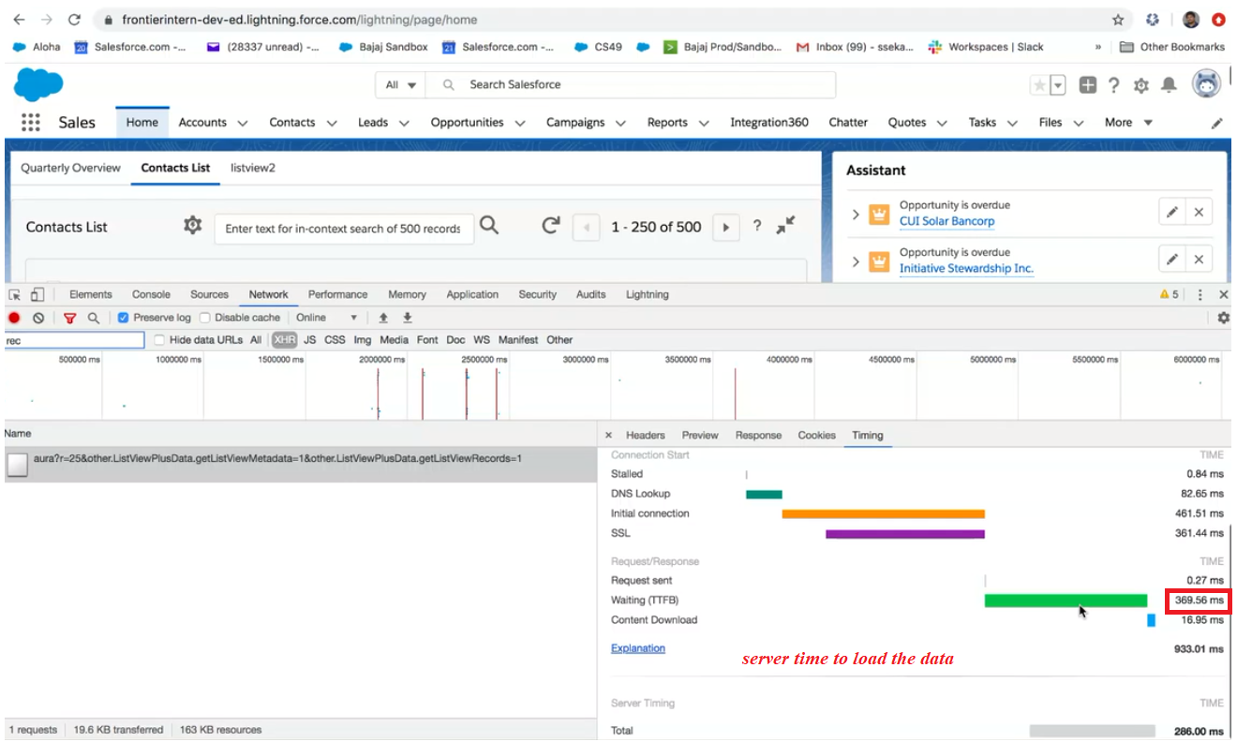

Tested multiple times by refreshing the page( below is the average time)

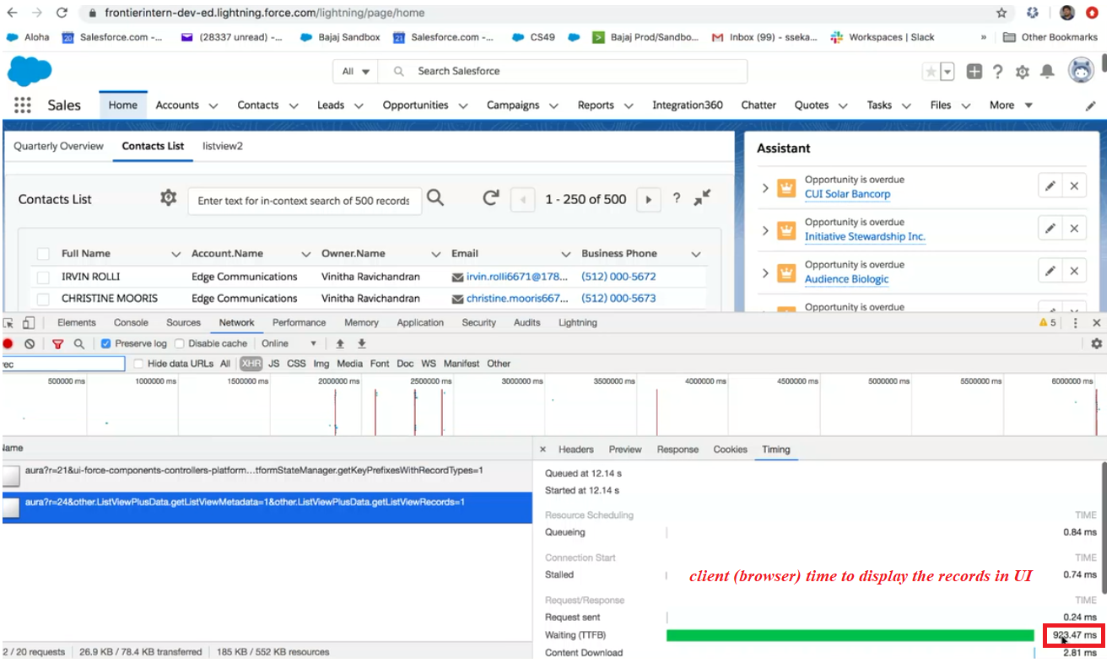

So, Server Processing time is less than Client processing time (JavaScript takes more time to render the page)

Tip-7

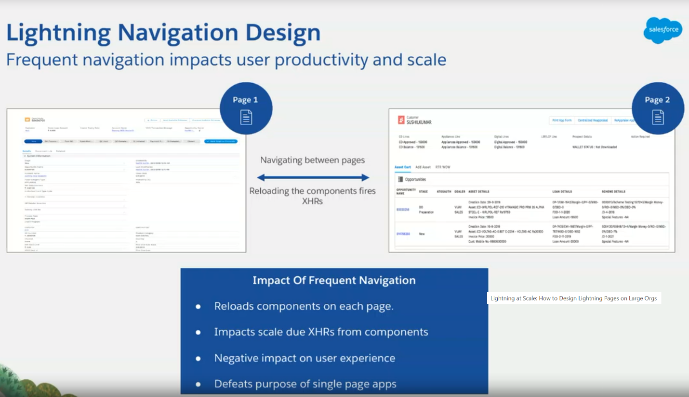

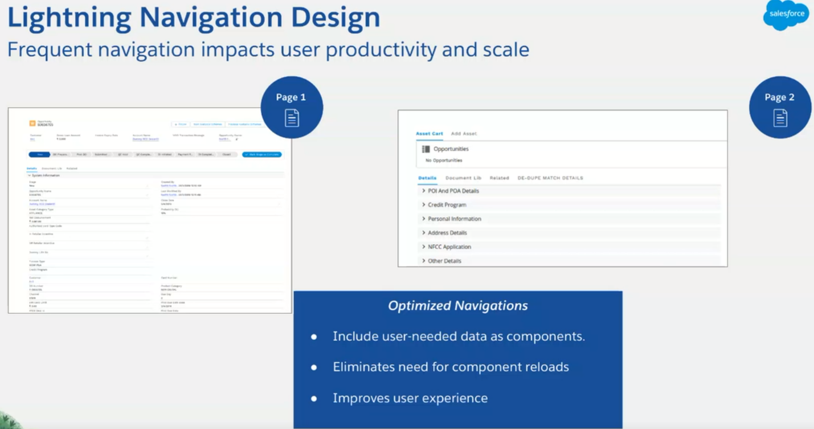

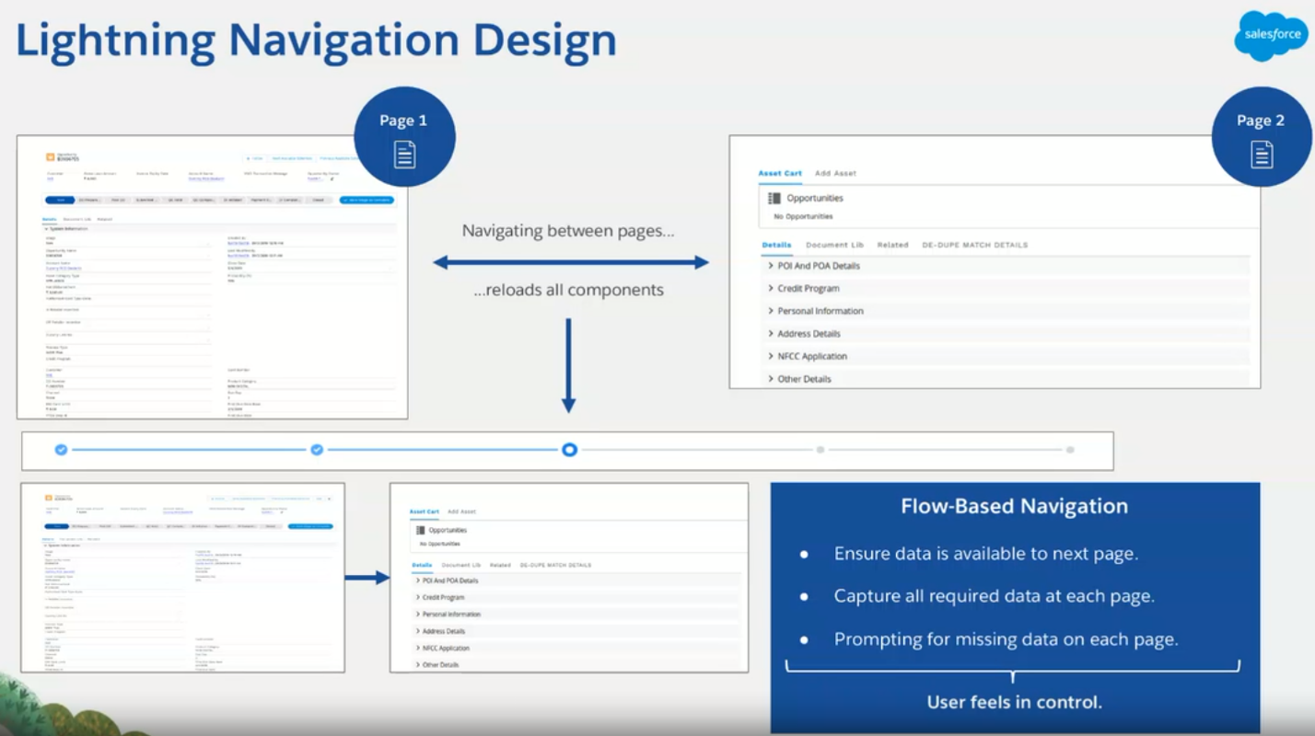

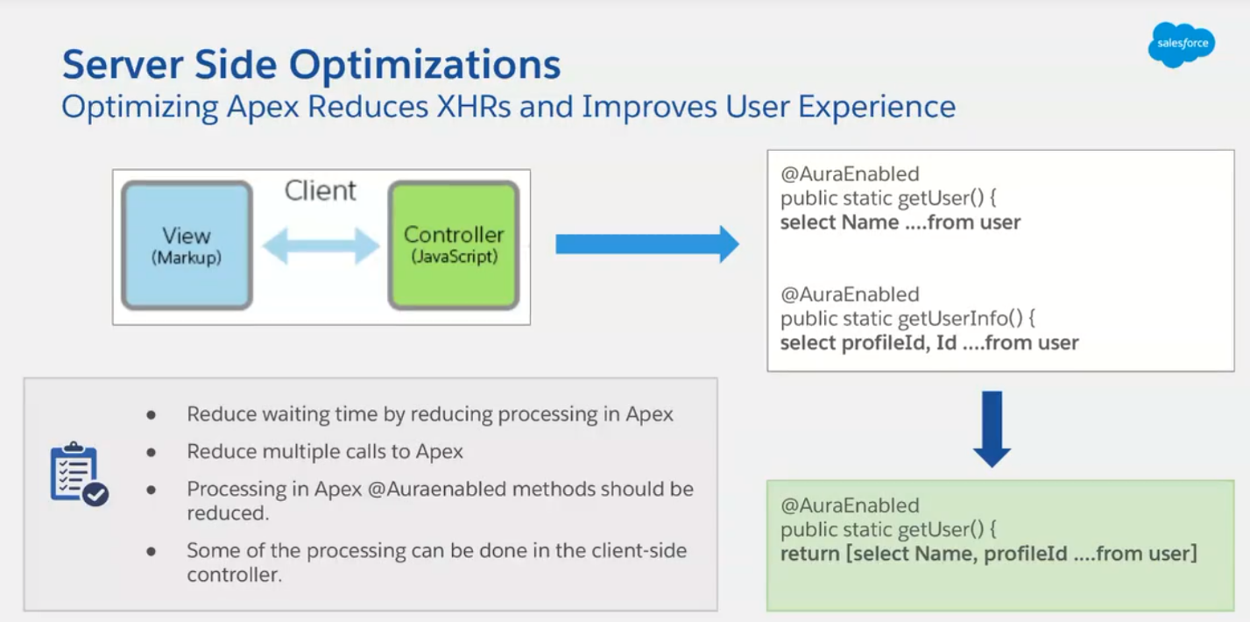

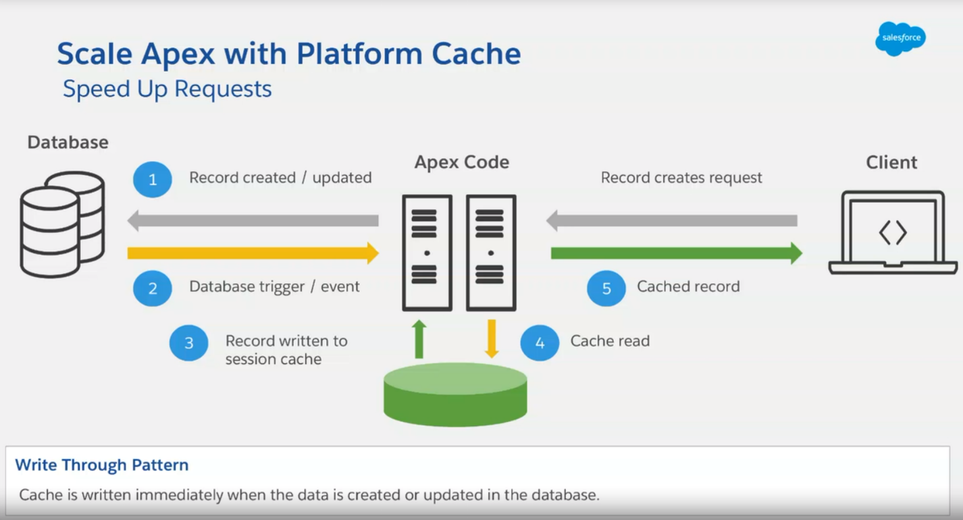

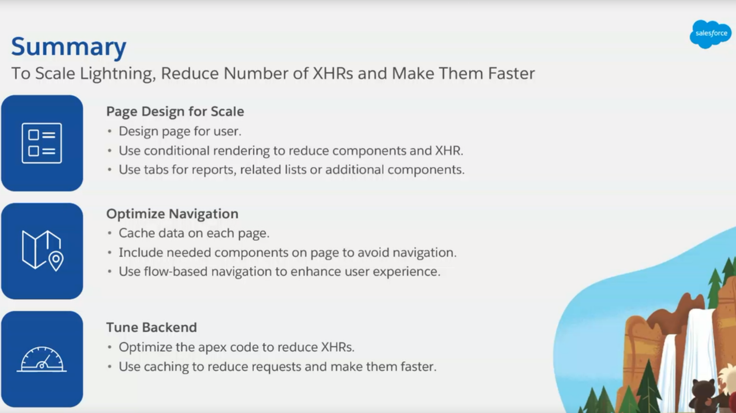

Few More Tips

* Reducing Fields: When setting up Lightning, users often have some 100-200 fields on the page, and this can lead to slow load speeds. Take some time to evaluate which fields are critical and reduce fields to what your clients will need.
* Related Lists: Active related lists can get bulky, so another way to speed things up is by minimizing the number of these on the page. Again, keep what you need, but get rid of the rest. Additionally, you might want to consider supplementing your related lists with related quick links. Related quick links allow users to access the information they need but does not require all the data to load onto the page.
* Disable unnecessary Plug-ins: Depending on the CPU power/memory resources, your plug-ins, and extensions use, you may have to disable some of them. Evaluate and test the plug-ins/extensions in your environment to troubleshoot which ones are causing slow speeds and then act accordingly.
* List Views, Reports, and Dashboards: To speed up the loading of list views, reports, and dashboards, avoid filtering by formula fields. Also, you should always try to filter by relevant date ranges so as not to query all records all the time (unless necessary). By filtering for date range, you will get faster results on filters for this year, Record Type, or any other picklist field. Also, when filtering on picklist or text fields, your results will query faster when you use “Equals” rather than “Contains.”
* Do not introduce too many locks especially while working on Batch Jobs.
* Try to avoid Junction objects.
* Stable Internet Connection: As a business user, a reliable internet connection is a must for your team. Again, Lightning relies on the browser and a reliable internet connection will be detrimental to the success of your Lightning integration. If necessary, switch to a different browser (for example, Salesforce notes that Chrome has performed more consistently than Internet Explorer). Just as well, ensure that the devices your team is on support the high CPU usage required to run Lightning. You can also do an [Octane](https://chromium.github.io/octane/) evaluation of your client’s devices to assess their browser processing capabilities.
* Restart Your Browser: It’s essential to maintain a consistent schedule for restarting your browser. Frequently, this helps limit the amount of devices/browser applications that are causing load speeds. By freeing up your resources, your operating system will work more efficiently and give more power to your Lightning Experience application.